Ideation Phase
Define the Problem Statements
Date | 18 June 2026
Team ID | N/A
Project Name | Book-A-Doctor Healthcare Appointment Management System
Maximum Marks | 2 Marks

Customer Problem Statement Template
This template helps understand patient challenges and define healthcare problems that the Book-A-Doctor platform solves.
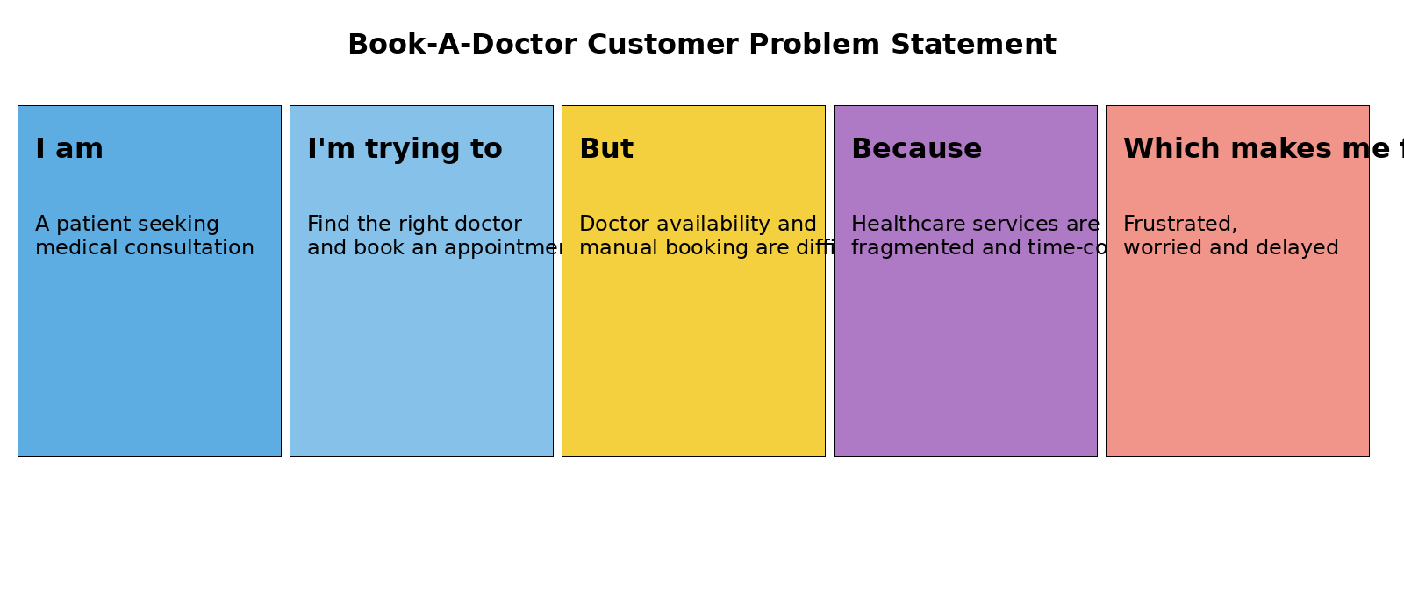
Reference: https://react.dev/ | https://nodejs.org/ | https://www.mongodb.com/docs/

Example Problem Statements
Problem Statement | I am (Customer) | I'm trying to | But | Because | Which makes me feel
PS-1 | Patient | Book an appointment | Doctors are difficult to compare | Information is scattered | Confused and delayed
PS-2 | Patient | Maintain medical records | Reports are stored manually | No centralized digital platform | Frustrated and worried

